class04.R

josierivera

2024-10-11

#my first rscript  
x <- 1:50  
x

## [1] 1 2 3 4 5 6 7 8 9 10 11 12 13 14 15 16 17 18 19 20 21 22 23 24 25  
## [26] 26 27 28 29 30 31 32 33 34 35 36 37 38 39 40 41 42 43 44 45 46 47 48 49 50

plot(x)

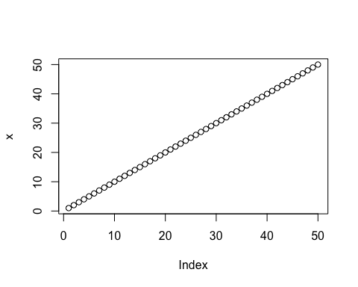

plot(x,sin(x),type = "l", col="blue", lwd=3)

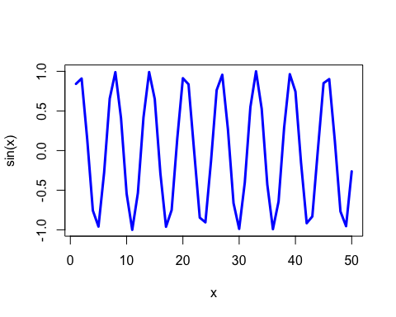

plot(x,sin(x),type = "l", col="red", lwd=3)

